SQL and SSIS Test
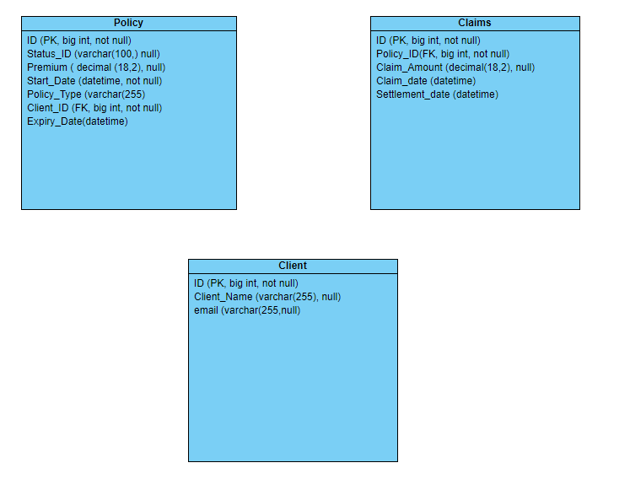
INSERT INTO policies (ID, policy_type, premium, start_date, status_id, expiry_date, Client_ID) VALUES
(1, 'Auto', 1200.00, '2023-01-15', 'Active', '2025-01-15',1),
(2, 'Home', 800.00, '2022-05-20', 'Active', '2024-09-20',2),
(3, 'Health', 1500.00, '2021-11-10', 'Expired', '2022-05-20',3),
(4, 'Auto', 1100.00, '2023-03-25', 'Active', '2024-09-20',4),
(5, 'Home', 900.00, '2022-07-30', 'Expired', '2023-05-20',5);

INSERT INTO claims (ID, policy_id, claim_amount, claim_date, settlement_date) VALUES
(1, 1, 500.00, '2023-02-10', '2023-02-20'),
(2, 2, 300.00, '2023-03-15', '2023-03-25'),
(3, 3, 700.00, '2022-12-05', '2023-01-10'),
(4, 4, 400.00, '2023-04-01', '2023-04-10'),
(5, 5, 600.00, '2022-08-15', '2022-08-25');

INSERT INTO clients (id, Client_Name, email) VALUES
(101, 'John Doe', 'jd@test.com'),
(102, 'Jane Smith', ‘js@test.com’),
(103, 'Alice Johnson', ‘aj@test.com’),
(104, 'Robert Brown', 'RB@nissan.com'),
(105, 'Emily Davis', 'EDavis@best.com');

Question 1:
Write a query to join the policies, clients, and claims tables to find the total claim amount for each client.

Question 2:
Write a query to calculate the running total of premiums for each policy type.

Question 3:
Write a query using a CTE to find the average premium for each policy type and then select policy types with an average premium greater than 500.

Question 4:
Write a query to find clients who have more than one policy with a premium greater than the average premium.

Question 5:

Write a query to pivot the claims table to show the total claim amount for each policy type in separate columns.

Question 6:
Write a query to unpivot the policies table to show each policy’s type as a separate row, for “Home” and “Auto”
Display the following columns : Policy_ID, Policy_Type, Premium

Question 7:
Write a query to extract the domain from the email column in the clients table.

Question 8:
Write a query to calculate the number of days between the start_date and expiry_date for each policy.

Question 9:
Write a dynamic SQL query to select all columns from a table whose name is stored in a variable.

Question 10:
Write a stored procedure to update the premium of a policy based on its Policy ID.

Question 11:
11. 1. Write a query to create an index on the policy id column in the claims table.

11.2. What is the difference between a non-clustered index and a clustered index?

Question 12:
12.1. Write a query to create a view that shows the total premium and total claim amount for each client.

12.2. Please elaborate what is the purpose of a view as well as the benefits:

Question 13:
Can you explain the difference between Life insurance and Short-Term insurance? Please provide 2 examples of each

Question 14:
Describe how you would use SSIS to deploy a job with notification - include data quality metrics

Question 15:
What is the purpose of the “Data Conversion” in the Data Flow in SSIS?

Question 16:
What is the difference between Data Flow and Control Flow in SSIS? Can you provide examples of tasks that belong to each?

Question 17:
What is the difference between a “#hash” table and a “##hash” table?

